

**Project: Vyntra Mart**

**Submitted to**

**Rajkumar Sivasubramanian**

**Members** : Venkata Anirudh

Ruthvik Sharma

Suraj Pandey

**Vyntra**

* E-commerce web application developed using Java 8, Spring Boot and MySQL
* This application begun as Virtusa intern Project in june 2020.
* It’s an e-commerce platform where you can look for products and signup to take as many products you want.

**ABSTRACT**

Electronic commerce, also known as e-commerce is a type of industry where buying and

selling of a product is conducted over electronic systems such as the internet.

The purpose of this application is to bring knowledge to students about e-commerce and

how an interactive e-commerce application can be designed from scratch using client-side

languages, such as JavaScript and HTML, combined with the server-side Java language through

Java Springs. The server side, mostly Java, contains all the implementation related to

setting up the database, creating session models for joining different user-interface (UI) pages,

calculating the shipping costs and sales tax, etc. It is responsible for taking information from the

database and making it available to the UI by mapping the category or item ID to the respective

IDs stored in the database. The client side is responsible for showing the entire user interface,

containing the javascript.

**Aim of the Software**

This software is developed to help students learn about application designing using JavaScript and

HTML from their basic capabilities. This application allows the student to understand the basics

about the appearance of a first web page and how a complete working application can be built from

scratch. It allows students to understand the concept of user-integrated design and how JavaScript

can be embedded into HTML. Further, it gives insight about how the client-side language interacts

with the server-side language, Java, and finally with the database. This shopping-cart application is

designed, primarily, for computer science students to learn and understand the concept of

application development, and can also be used to teach e-commerce and web-application topics.

The application can be downloaded and installed on different machines, and students can view the

source code for all the different parts shown on the UI to visually understand how a particular piece

of code works. This shopping-cart application is very versatile and can be enhanced by adding more

functions and modified graphics for use with commercial purposes.

**INTERFACE**

**User Interface**

The two interface types found in the online shopping-cart application are as follows:

**1. User Interface**: Users are able to view the home page of the shopping-cart application,

browse the different categories, browse and add any number of items from any categories in

the shopping cart, look for information about each product, delete the items in the shopping

cart, save the cart for later viewing, check out or continue shopping after adding the item to

the cart, and check out the items by completing the required information in the order form.

**2. Admin Interface**: The administrator is able to view the users’ information that was entered

during checkout in the database, can update the information, price, shipping costs of the

items, add or remove items from the main display.

**Hardware Interface**

The online shopping-cart application shall provide minimum hardware requirements. The

following hardware configurations are required for a PC using the online shopping-cart

application:

* Pentium processor
* 32 MB of free hard-drive space
* 128 MB of RAM

**Software Interface**

This section lists the requirements that are needed to run the system efficiently. The

operating system needed for the system to run effectively, the interface to run the application, the

driver for running Java web applications, the integrated development environment to develop the

application, and the third-party tool used for editing purposes are as follows:

1. Operating System: Windows (Vista/Windows 7) or MAC OS

2. Web Browser: Internet Explorer (8.0 and above), Mozilla Firefox (3.0 and above), or Google

Chrome

3. Drivers: Java Runtime Environment

4. Integrated Development Environment: Eclipse or Spring Tool Suite

5. Third-Party Tool: Microsoft Word

**Product Function**

The online shopping-cart application would have the following basic functions:

1. Display all the categories available for shopping on the system’s main page.

2. Display all the items linked to each category listed on the main page.

3. Allows the administrator to add new items to the existing list of available items.

4. Allows administrator to remove items.

5. Allows the administrator to modify the price of each item.

6. Allows the administrator to update the description about each item.

7. Allows the administrator to view and edit information about each user that checkouts the

items from the system.

**User Characteristics**

The users of the online shopping-cart application, based on their roles, are customers

(users) and the administrator (owner). These users are identified based on their experience and

technical expertise.

1. **Admin:** The administrator is the owner of this online shopping-cart application. One must

have a basic understanding of computers and the internet as well as prior knowledge for

operating the eclipse and Java programming languages. The administrator is responsible for

maintaining all the training documents required for the system. The administrator can

perform the following functions:

Assign or change the price of the items, update the items in the list, and delete the items.

Assign sales tax for different states at the time of checkout.

View the history of the customers who purchased the items.

2. **Users:** The users of this online shopping-cart application are all customers who would shop

to test the application. These users are anyone with shopping experience and the know-how

to browse through a shopping-cart application. They must have basic understandings about

computers and the internet. The users should be able to perform the following functions

using this system:

* View, browse, and select a category on the home page.
* View, add, and update items in the cart.
* Delete items from the cart.
* Check out the items from the application or continue shopping.
* Sign-on/login using a username and password.

**Use Cases**

* Admin Usecase
* User Usecase

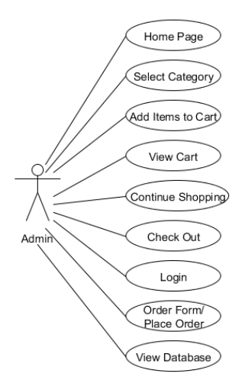

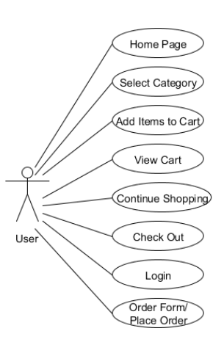

DATABASE DESIGN

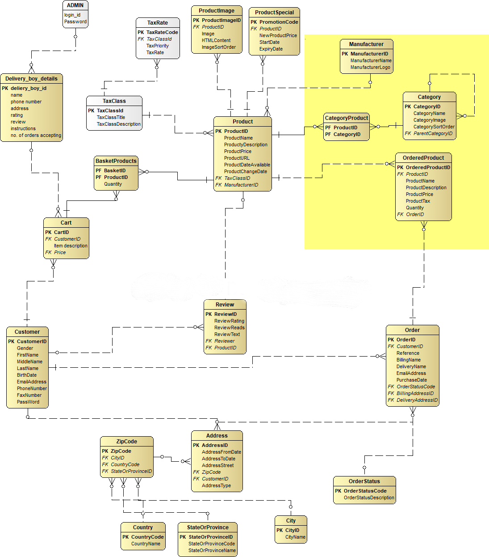

**The Vyntra Mart Application Interface**

This section describes the different interfaces for the vyntra online shopping-cart application. It

contains a detailed description about each interface along with a screen shot of the interface.

**Home Page**: The home page of the application is common to all the system users/administrators.

This interface is available through the web application. This page contain features to register, login a

a user and also a user/non-user can go to vyntra page where he/she can see the products available

in the site.

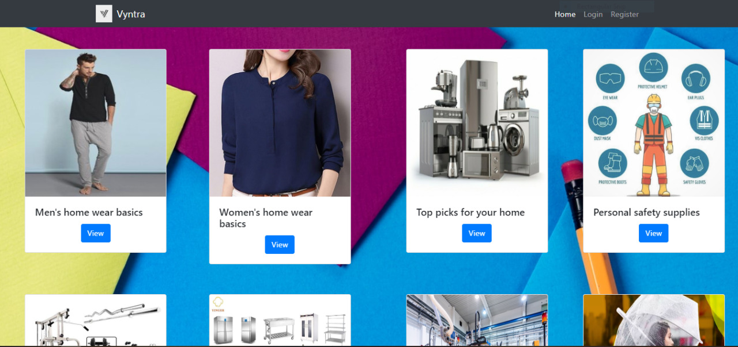

**Register Interface:** The user can register to this shopping site by providing the details required in

the registration page. Once the registration has successfully done, the user will be redirected to

login page.

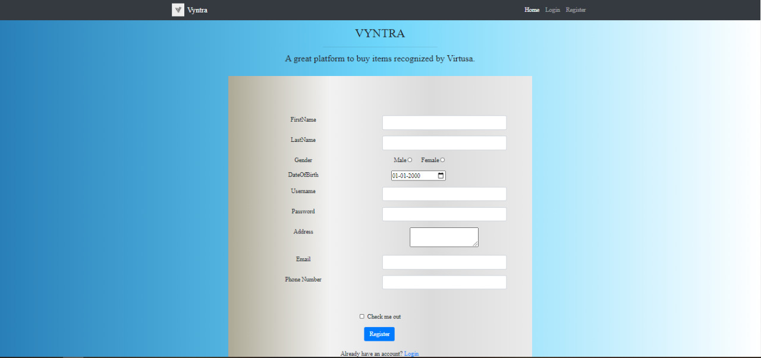

**Login Interface:** Once the registration has done the user will be redirected to login page.

He/she has to provide the valid credentials i.e. username and password which was created during

registration, in the login page in order to view/buy the products.

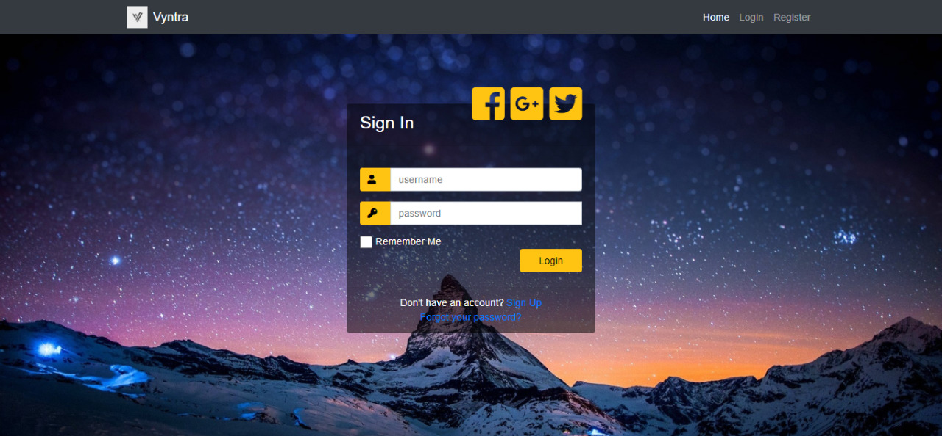

**Vyntra Interface:** This page shows the categories available for shopping. By default,

there are six categories:

a. Men’s Home wear basics

b. Women’s Home wear basics

c. Top picks for your home

d. Personal safety supplies

e. Home Gym equipment

f. Kitchen and Home Appliances

g. Industrial and scientific Appliances

h. Monsoon essentials

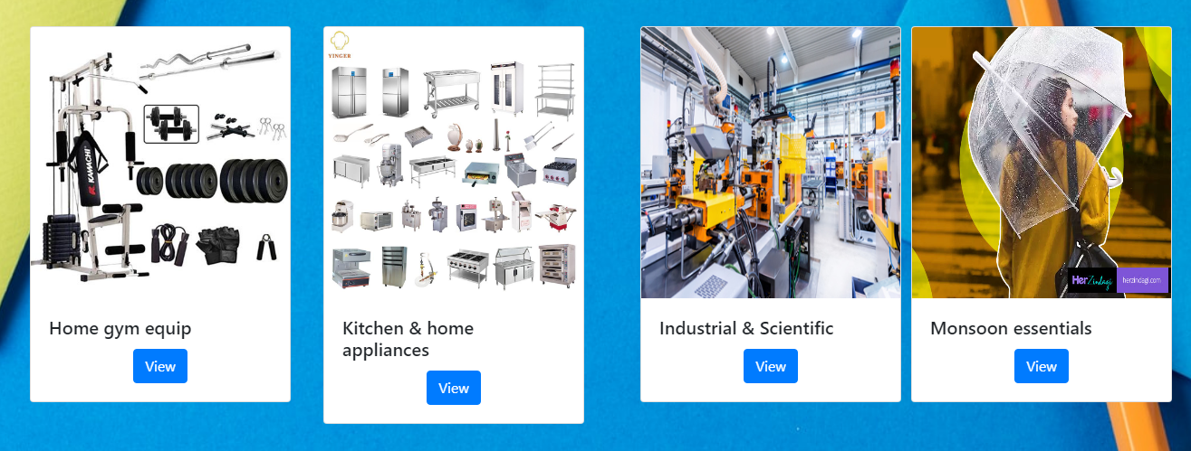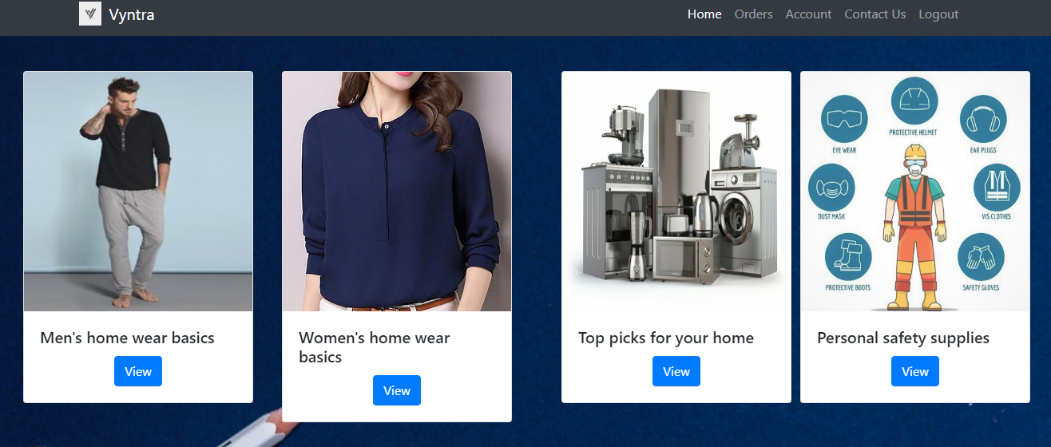

**Men’s Home wear basics**

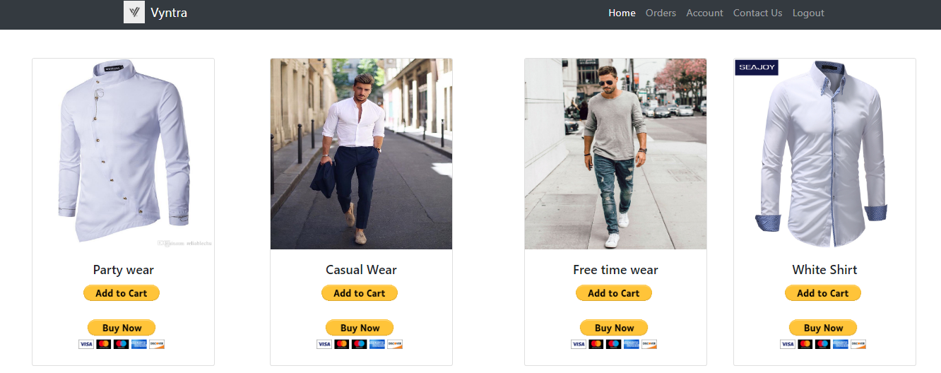

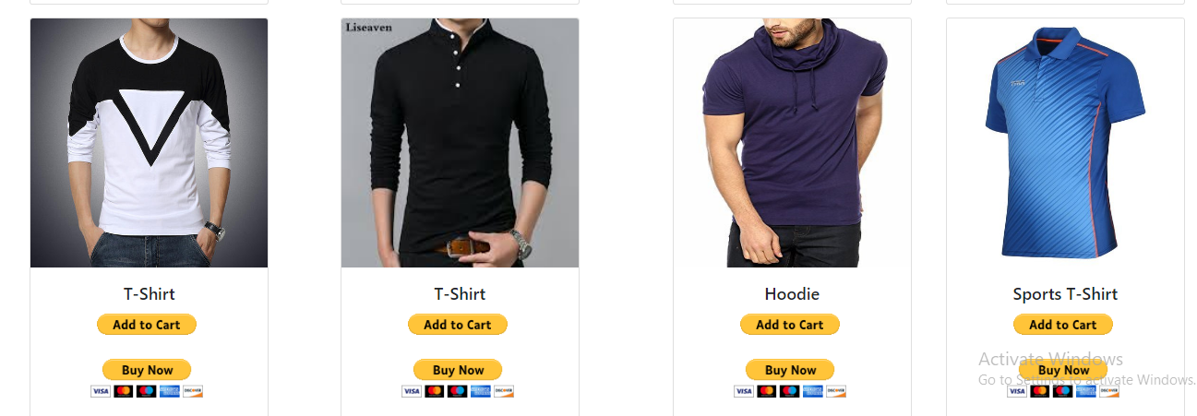

**Women’s Home wear basics**

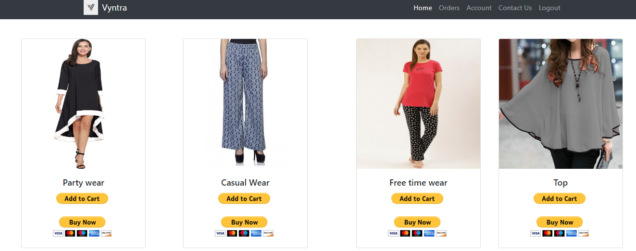

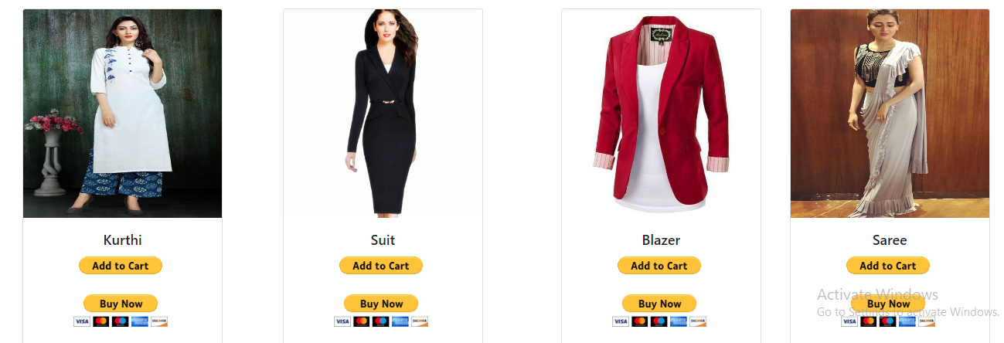

**Top picks for your home**

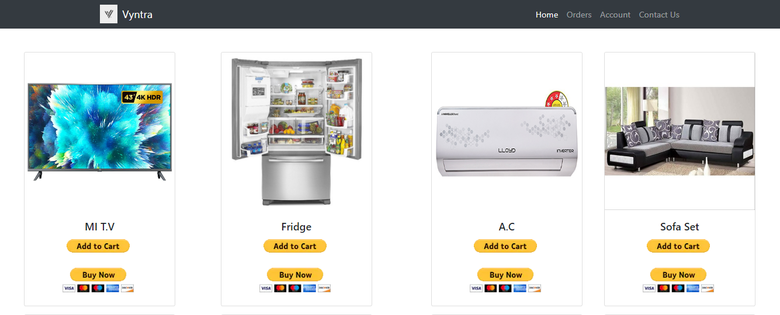

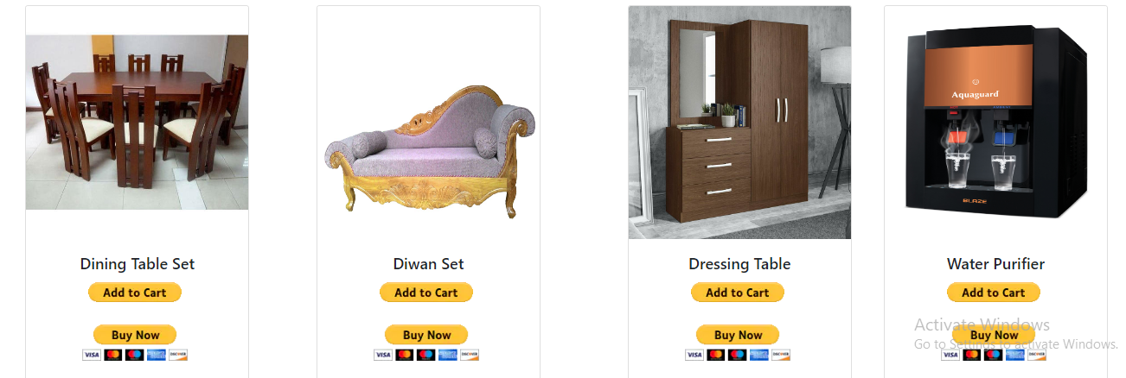

**Personal safety supplies**

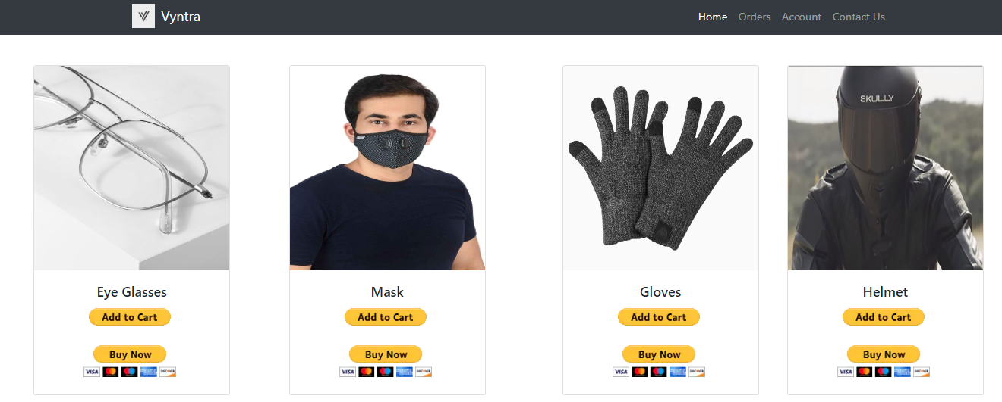

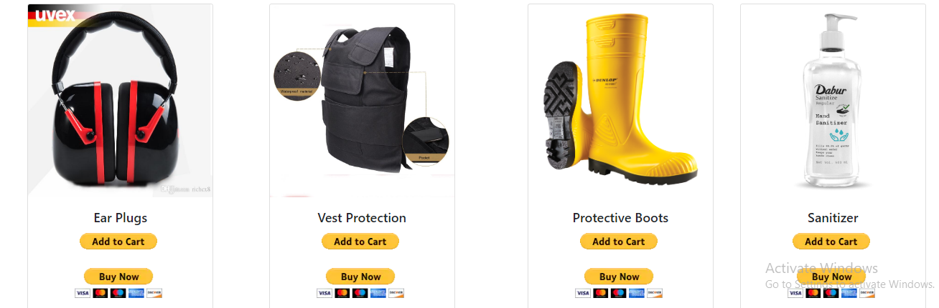

**Home Gym equipment**

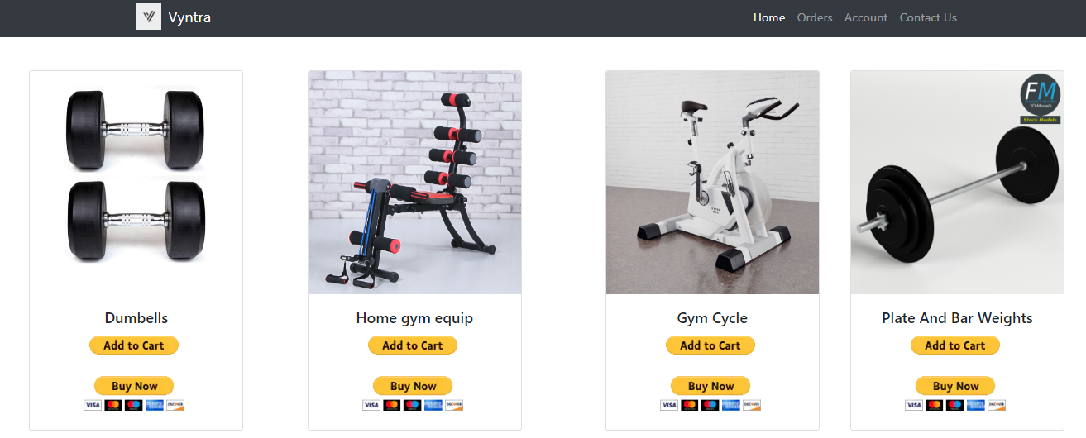

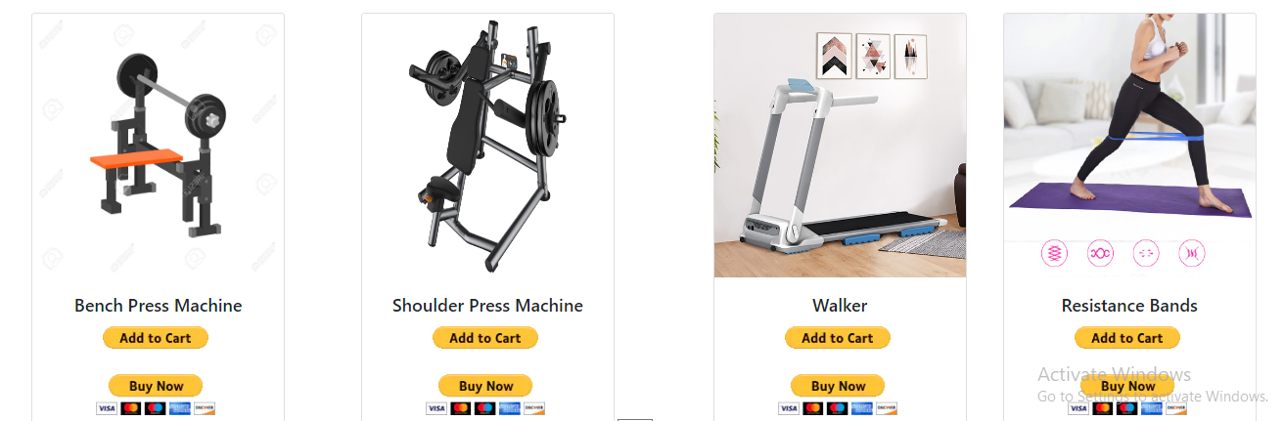

**Kitchen and Home Appliances**

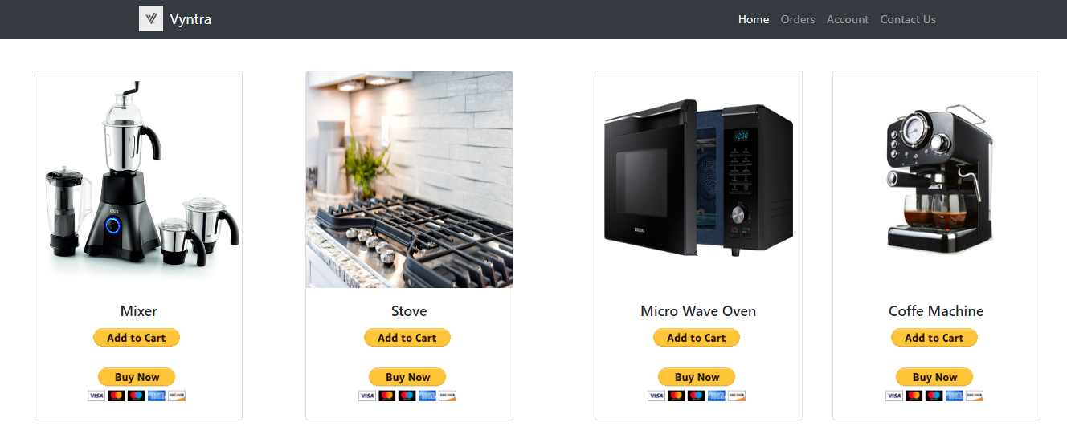

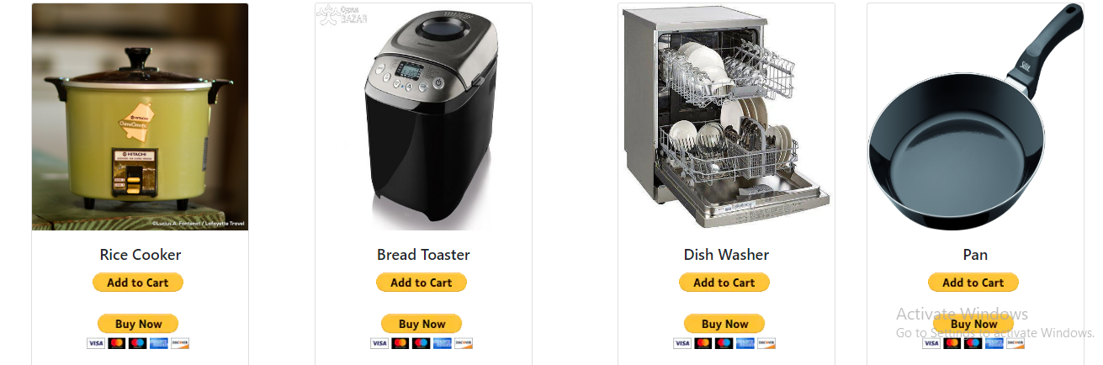

**Industrial and scientific Appliances**

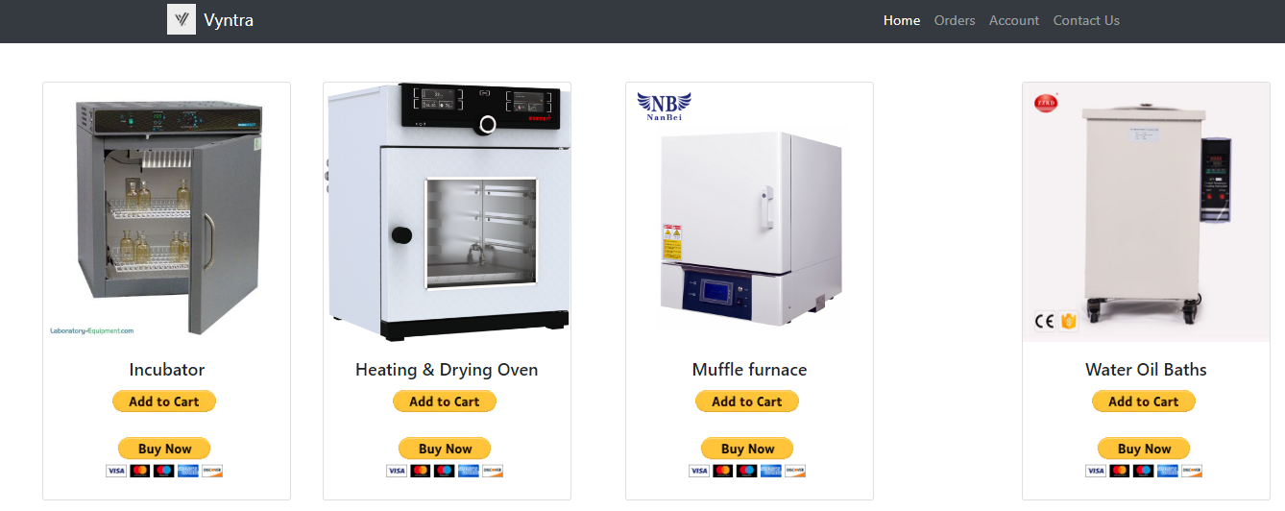

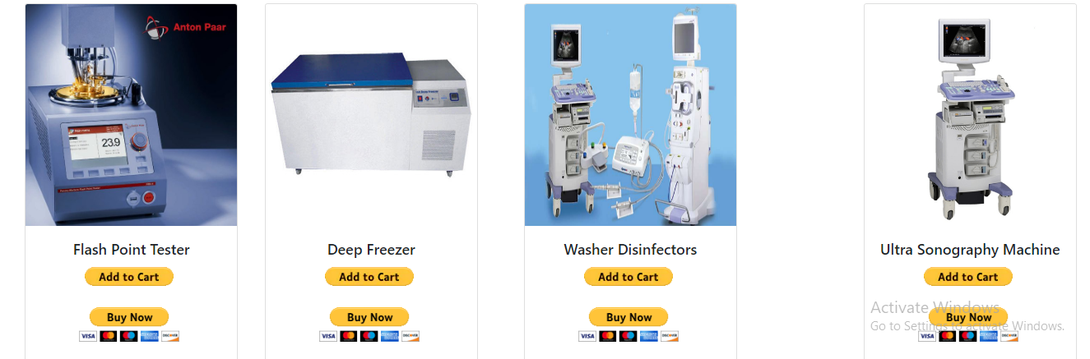

**Monsoon essentials**

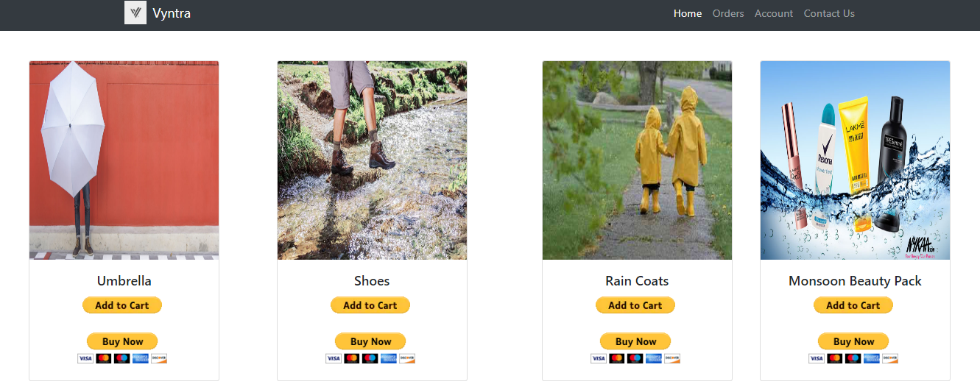

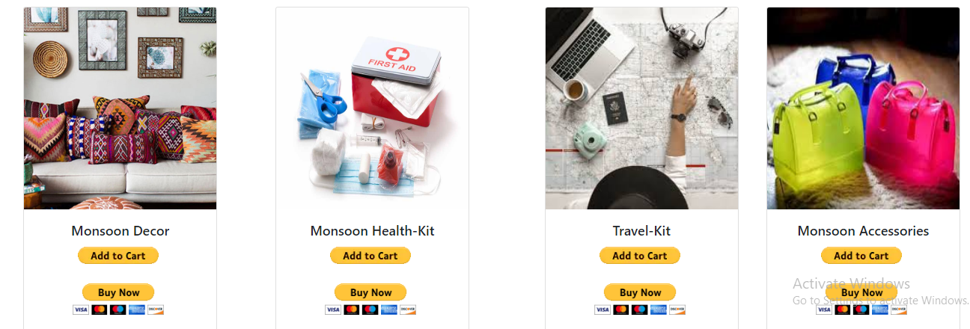

**Cart**

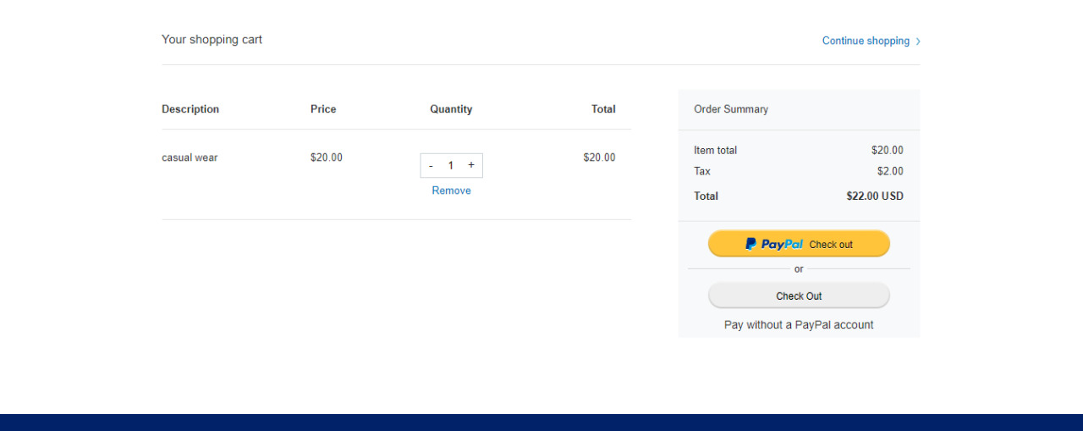

**Database Interface**

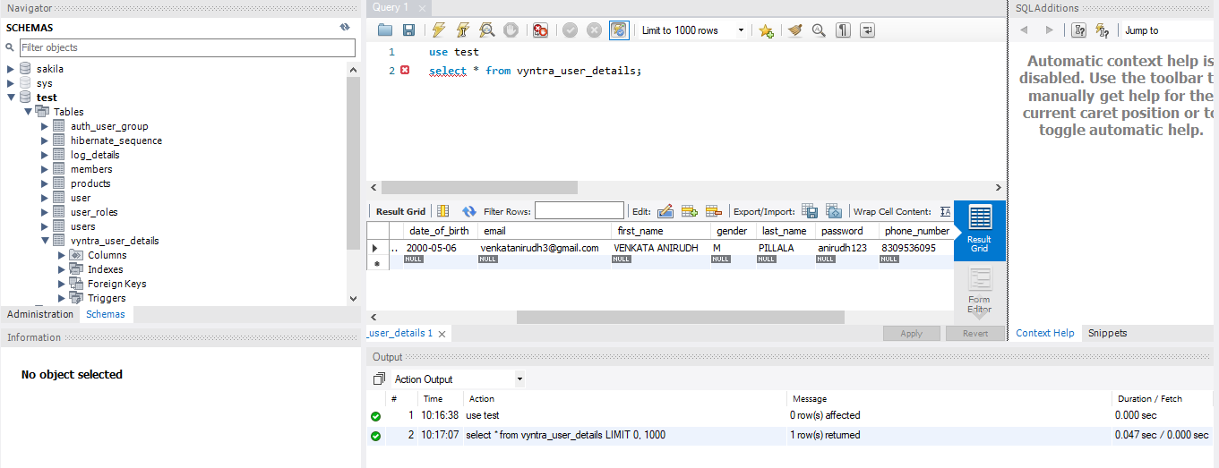

**Admin Panel**

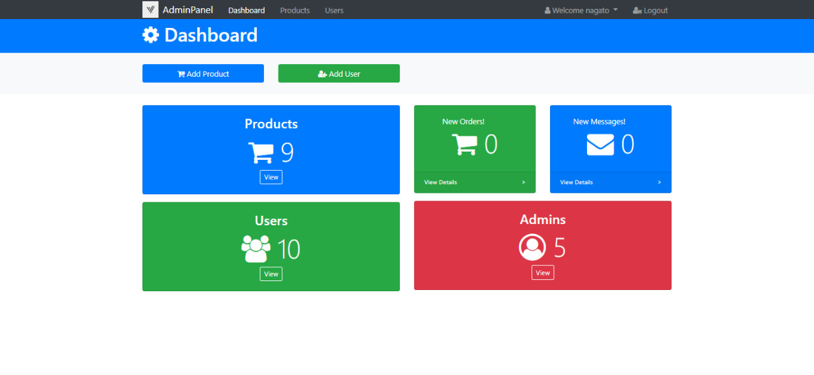

**Users list**

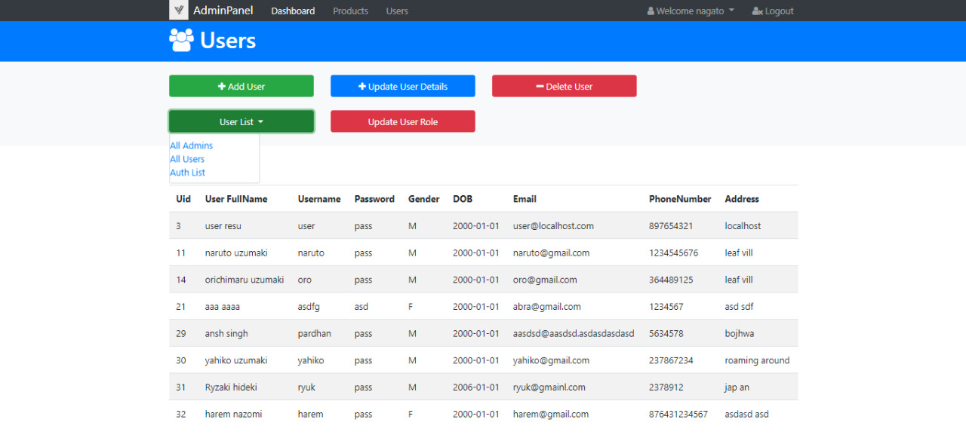

**Add User**

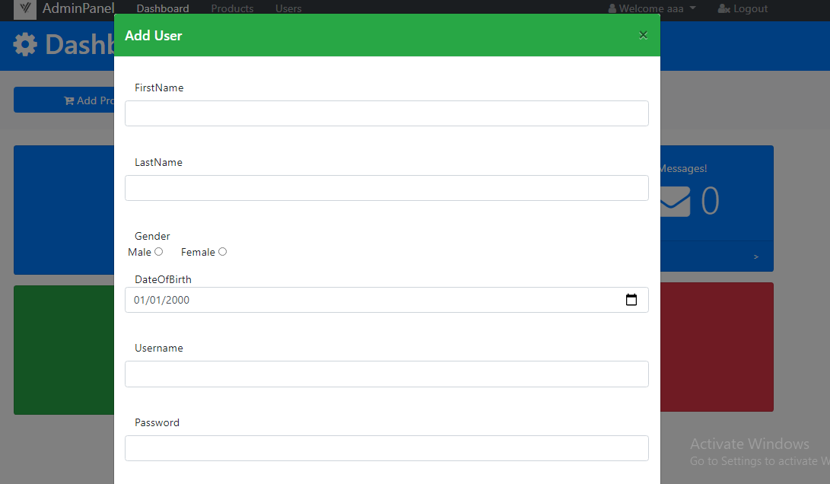

**Edit User Role**

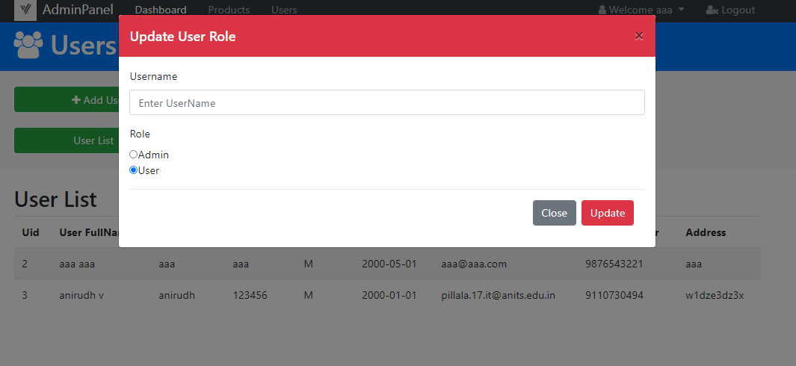

**Update User**

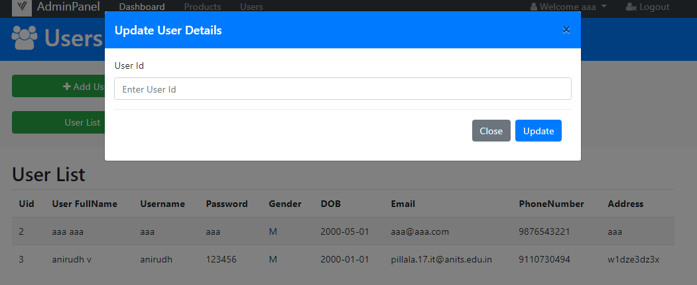

**Products list**

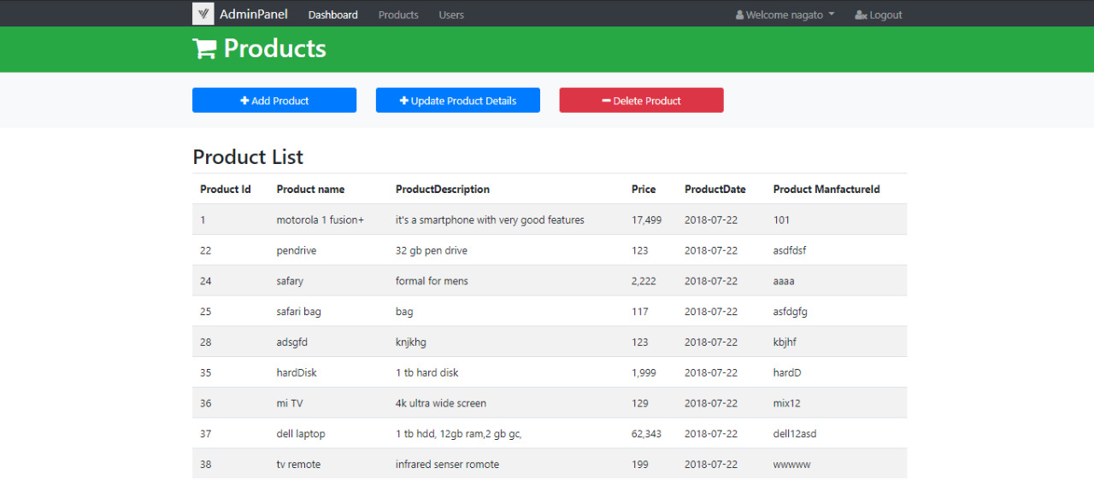

**Add products**

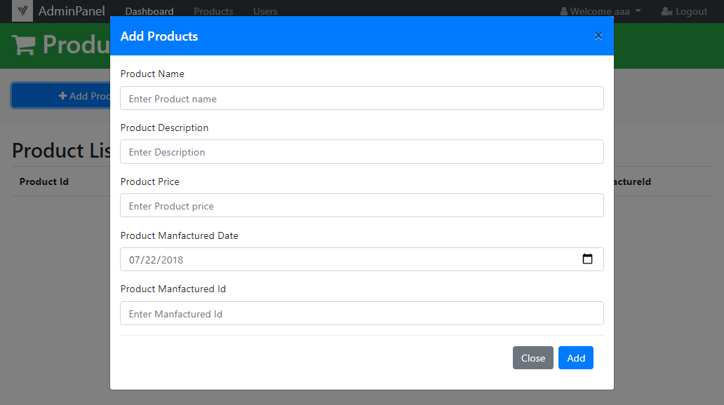

**U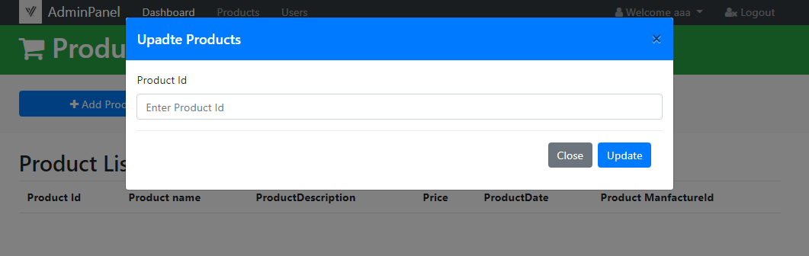pdate Products**

**My Account**

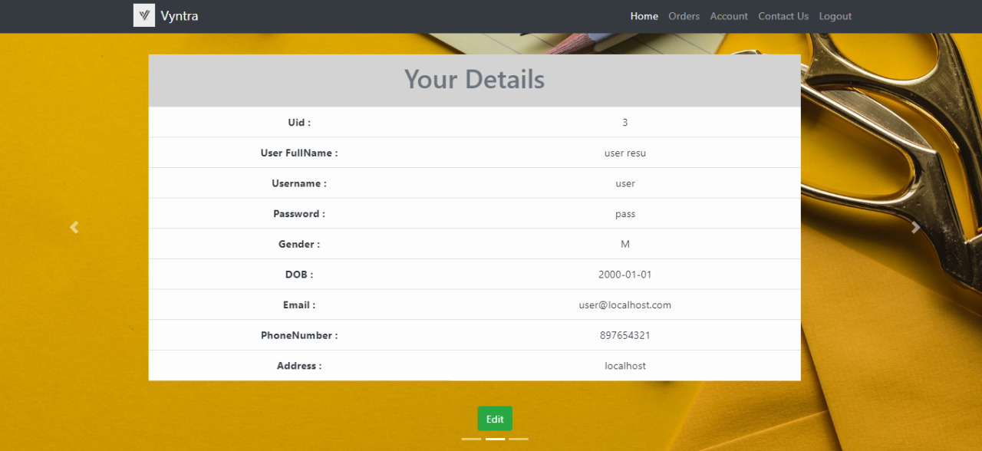

**Edit User Details**

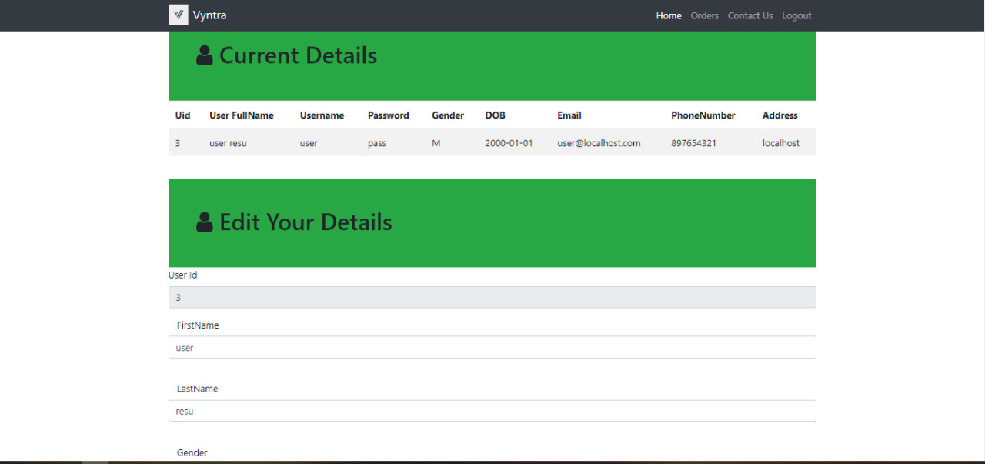

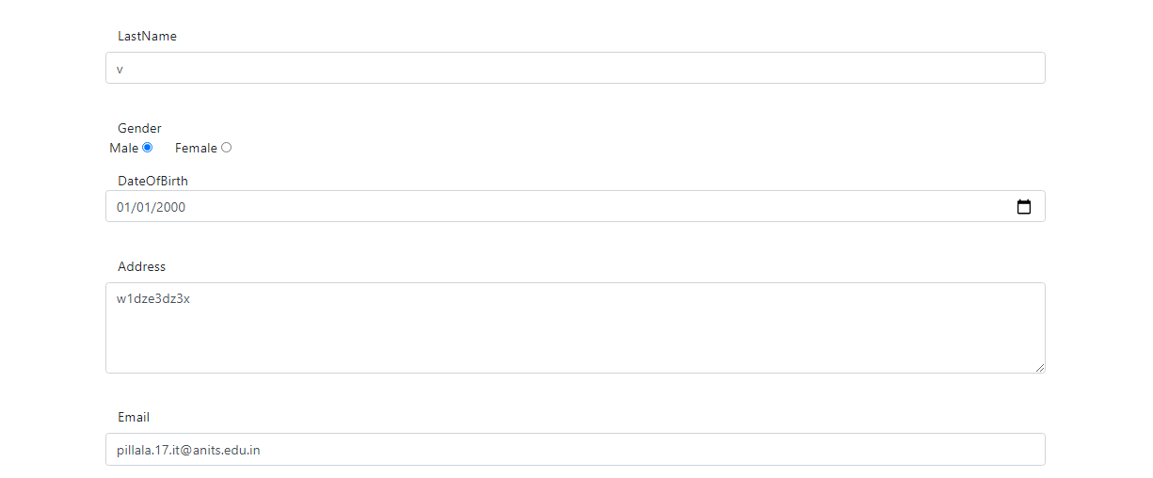

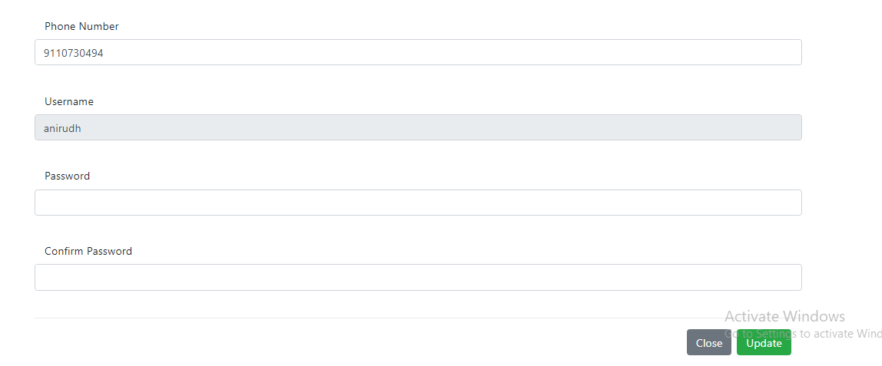

**Error**

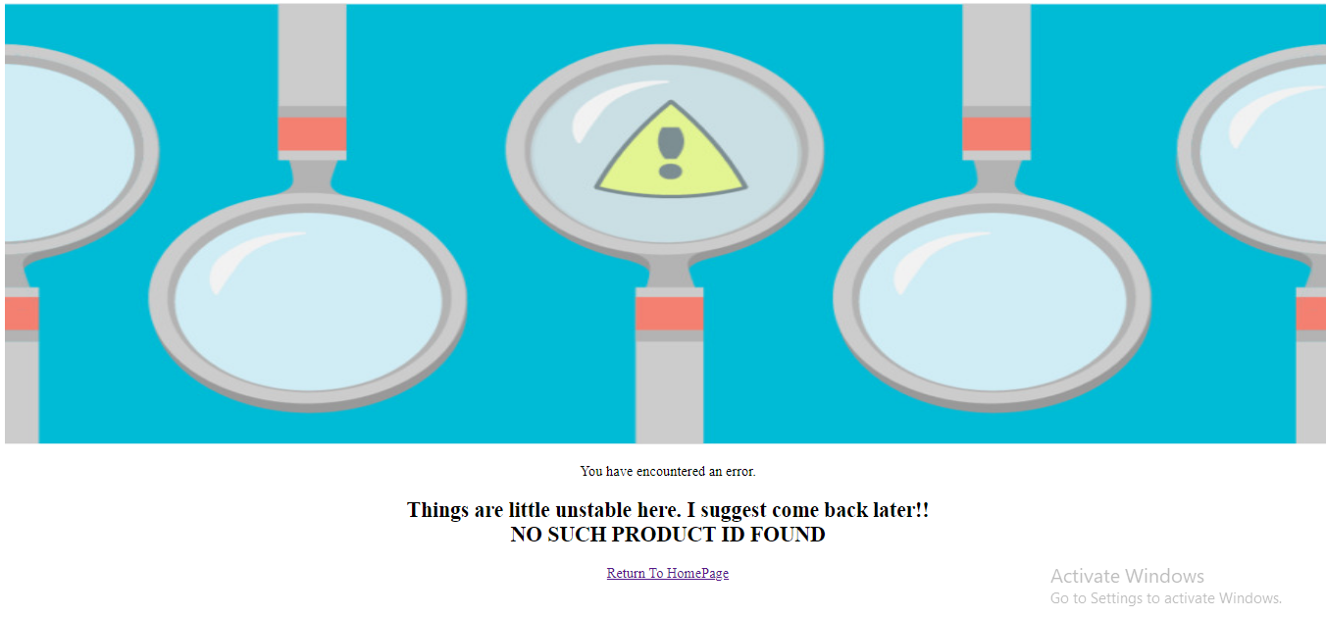

**CONCLUSION**

By browsing through the application and looking at the code for each graphical interpretation,

one should be able to easily understand the implementation. The following results have been

achieved after the completing the system and relate back to the system’s objective.

**1.Should allow users to register or login :** This is achieved when the user first runs the application

and is directed to a home page that has an availability to register or login a user with this online

shopping-cart application. The user can register or login or can view the items listed of all categories.

**2. Should allow users to browse through different product categories:** After successful registration,

the user will be redirected to login page to browse the items. The user can find his/her item in the

products list and should select buy option or add to cart option for proceeding to checkout.

**3. Should allow users to pay using paypal:** After selecting the items of user’s wish, Clicking the buy

option should redirect to paypal where the user can make payment successfully.